How I make a Dress

I do not claim that this is the way every Viking/Saxon/Norman woman made a dress. I doubt that there was a set way and everyone approached it in their own way. This works for me, however. I must thank Gale Owen-Crocker for the method of cutting and Lilli Fransen, Anna Norgaard and Else Ostergard (who worked together to produce ‘Medieval Garments Reconstructed’) for the sewing ideas. Not to mention all the other people whose work I have studied to come up with this method.

Cutting out

I am assuming that I have 150mm/60 inch wide cloth. As I am not that well-endowed by the goddess Freya I can cut the front, back and side-gores from a single width of such fabric. Those to whom the goddess was more generous will want wider panels and will need another couple of metres/yards of fabric. I find 3 metres does for me.

First I fold the fabric lengthwise then I cut it as below:

Selvage

Cut here

Fold of fabric

Front and Back

Gores

Next I pin and sew the long sides of the gores (I do not cut the fold, this saves me having to neaten one seam). I neat the seam with the raw edges by folding the edges in and oversewing, if the fabric is thin. If it is thick, I just oversew. Once I have done this I cut the gores diagonally as shown in the diagram. I do allow for a seam when cutting the gores.

Gores

Gores

Gores

Cut here

Seam on raw edge which needs neatening

Seam on fold

For the centre gore I repeat this stage but on a piece of fabric that is 1 foot (30cm) shorter.

Next I cut out the sleeves as follows:

The wide end is the shoulder. The wedge cut off at the wrist is turned and added from the wide end to the mid-point. I do this bias to straight-edge. It gives you a useful gore. If you need a wider sleeve at the shoulder-end you can use the bit you cut off the side-gores, as below:

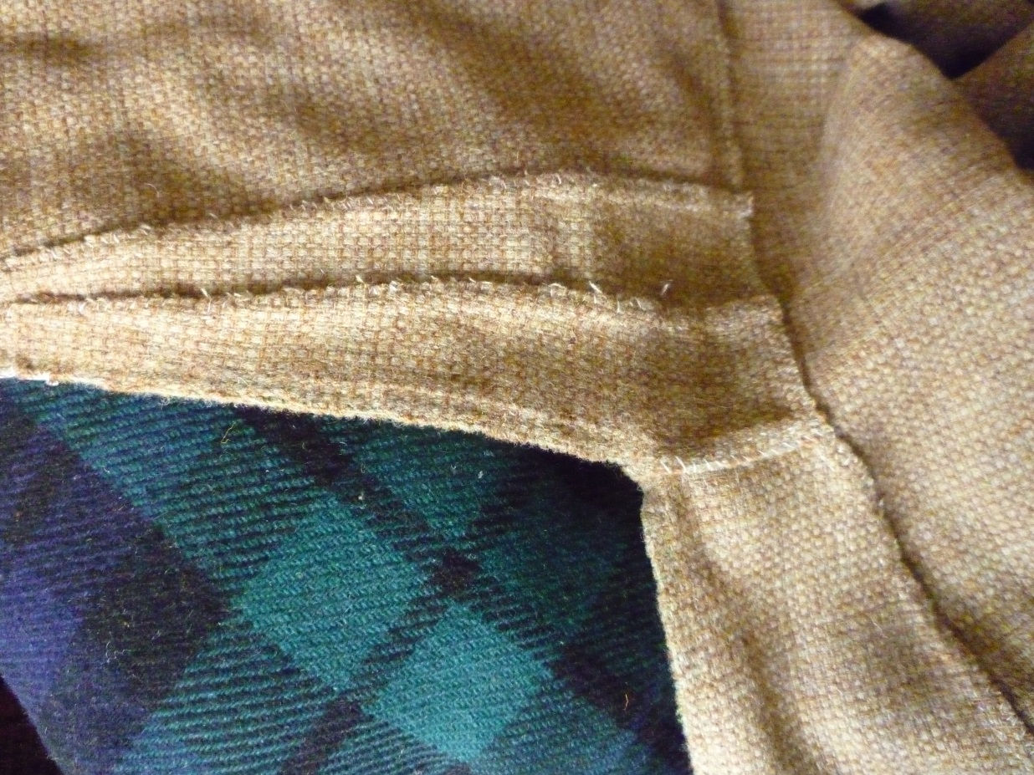

Assembling the dress

First I sew the front and back together at the shoulders. I usually taper down to the sleeves by about 1 inch (2.5cm). (I trim the fabric from the neckline to the shoulder.)

This is when you should decide what sort of neckline you want. This will affect how wide the neckline is. The evidence is for boat, round or square with or without slits. Said slits can be in the middle of the front or, on square necklines, extending down one side of the neckline. In other words, you can use whatever shape you want. Once I have done the shoulder-seams I sort out the neckline to avoid it fraying while I am sewing other seams.

The next stage is to attach the sleeves, which are not yet sewn up.

Having done that, lay the side-gore against the dress, seamed side to the edge of the front/back. Cut off the top of the triangle so that the gore is the same length as the front/back, remembering to allow for a seam! I usually give an inch (2.5cm) overlap which gives a half-inch seam allowance on both pieces. I cut both gores the same.

Attach the bias sides of the side-gores to the front and back of the dress.

Attach the sleeves to the top of the side-gores.

Stitch up the sleeves and hem the wrists.

Hem the dress.

Stitches used

I hand-sew my dresses because I choose to do so. I use the following stitches as they are the ones found at Herjolfsnes according to ‘Medieval Garments Reconstructed’.

All my seams are sewn using a running stitch. However, I sew my running stitches by stabbing the needle through the fabric, pulling the thread through, then stabbing back through the fabric and pulling the thread through 4 fabric threads later. (If I am following a warp thread, eg when joining front to side-gore, that will be 4 weft threads.) This gives a neat finish with even, small stitches.

On the shoulder seams only, I open out the seam and oversew the raw edges to the front or back, using the old trick of catching one thread on the front/back that is masked by a cross-thread on the right side. This gives you an invisible stitch and works on fine linen if you are careful enough. If you are sewing a fine fabric, tuck the raw edge of the seam under and stitch through the fold or it will fray badly. The picture above is tweed which was too thick for that.

All other seams I flat-fell. Again, if using a fine fabric I sew up the seams with the gore-side slightly longer than the front/back side so it can be wrapped over and sewn to the front/back on the fold. This gives a lovely drape as the gores naturally settle under the front/back. Sleeve seams are flat felled towards the back but with a cord or strong thread along the seam to help maintain shape in use as this is a bias seam.

Hems I edge with a stab-stitch that is angled so that it catches the previous stitch. Again, this is from ‘Medieval Garments Reconstructed’. Once I have done that I trim the hem and oversew it either over a cord made on a lucet or a strong thread. If you want to be really fancy you can use 2 threads catching down 1, then twisting over the other to catch that down and so on. It is fiddly but gives a nice effect.